**Machine Learning : Linear Regression**

**Regression – mapping our data features on to a target label where the target takes on a continuous value.**

**Goal**

* **Map data X to real value Y**
* **Linear regression, mapping is linear function of X**
 $h_{θ}(x)=θ_{0}+θ_{1}x_{1}+θ_{2}x_{2}+…$

 + **Hypothesis function $h_{θ}\left(x\right)$**
  + **Sub $θ$ = All the parameters that define that function**
  + $θ_{0}+θ_{1}x_{1}+θ_{2}x_{2}+…=$**linear combination of input features**
 $x are the feature values, θ are the weights (coeficient)$

 $θ_{0}=$ + **y-intercept**

$h\left(x\right)=\sum_{i=0}^{D}{θ_{i}x_{i}}$

$x_{0}=1$

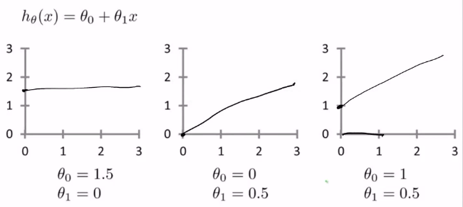

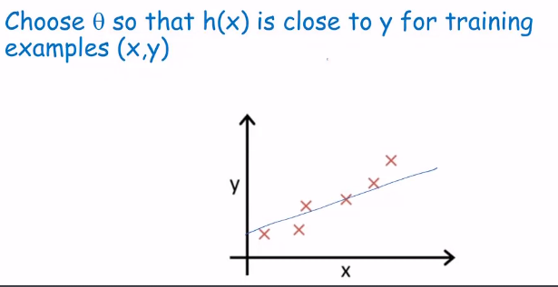

* **Goal of linear regression is to minimize over the space of multiple parameters**

$min θ_{0},θ_{1} {\left( h\left(x\right)– y \right)}^{2}$

$minimize θ_{0}, θ_{1}\frac{1}{2n}\sum_{i=0}^{n}{{\left(h\left(x^{i}\right)-y^{i}\right)}^{2}}$

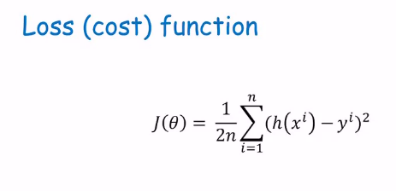

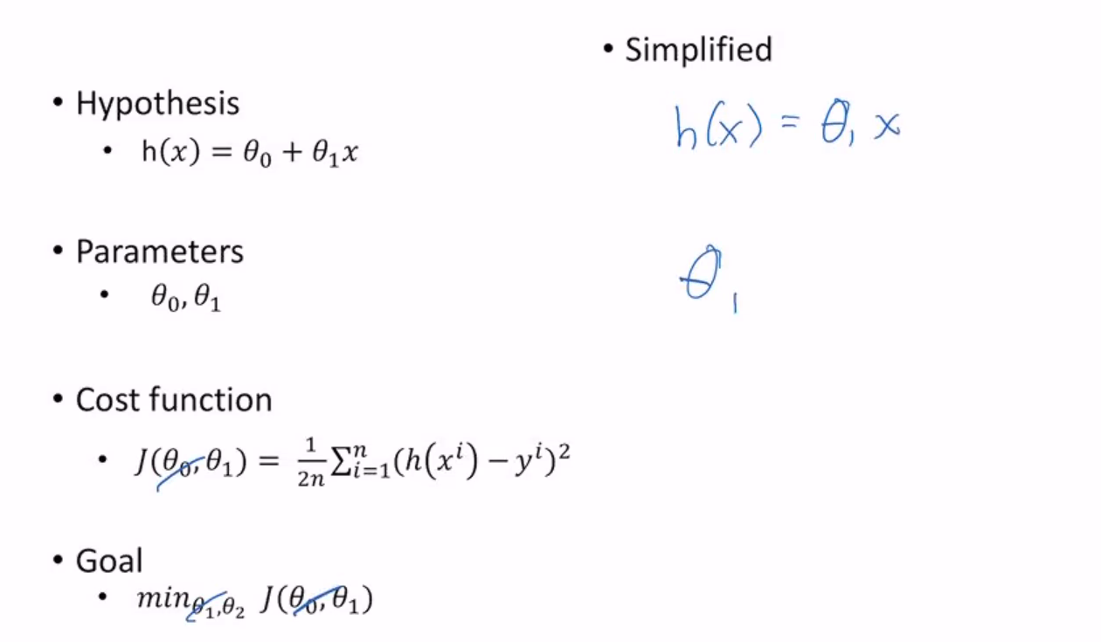

**First Point**

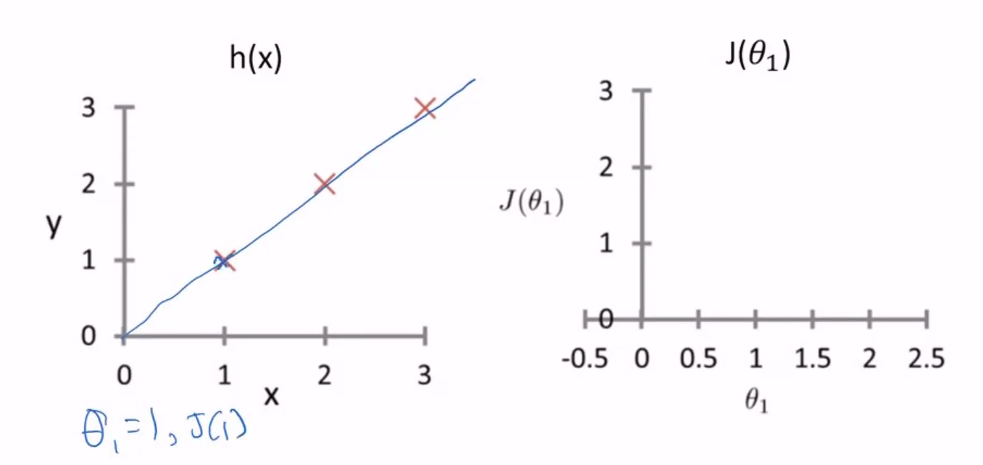

**Second Point**

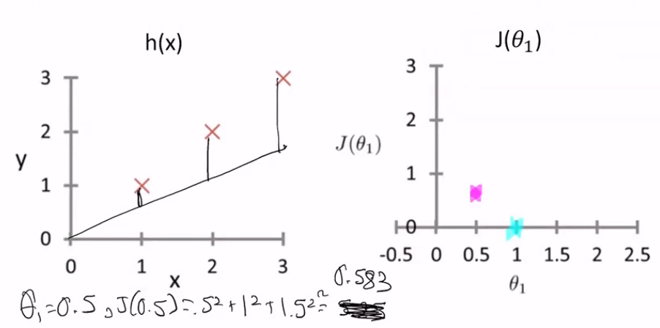

**Third Point**

